RESTful Day 1: Enterprise Level Application Architecture with Web APIs Using Entity Framework, Generic Repository Pattern and Unit of Work

( <https://www.c-sharpcorner.com/UploadFile/1492b1/restful-day-1-enterprise-level-application-architecture-wit/> )

* [Akhil Mittal](https://www.c-sharpcorner.com/members/akhil-mittal4)

* May 10 2015

[**databasescript.zip**](javascript:void(0);)**|**[**PdfArticle.zip**](javascript:void(0);)**|**[**WebApi.zip**](javascript:void(0);)

[Download Free Office API](https://www.c-sharpcorner.com/AdRedirector.aspx?AdId=121&target=https://www.e-iceblue.com/Introduce/spire-office-for-net-free.html?aff_id=100)

**Introduction**

I have been practicing and reading a lot about RESTful services for the past few days. To my surprise, I could not find a complete series of practical implementations of ASP.Net Web APIs on the web. My effort in this series will be to focus on how to develop basic enterprise-level application architecture with Web APIs.

We'll be discussing less theory and doing more practice to understand how RESTful services can be created using an ORM. We choose Entity Framework here. My first article in the series is to set up a basic architecture of a REST service-based application. Later on in my future articles, I'll explain how to follow best standards to achieve enterprise-level architecture.

**Roadmap**

My road map for the series is as follows:

* [**RESTful Day #1: Enterprise-level application architecture with Web APIs using Entity Framework, Generic Repository pattern and Unit of Work.**](http://www.c-sharpcorner.com/UploadFile/1492b1/restful-day-1-enterprise-level-application-architecture-wit/)
* [RESTful Day #2: Inversion of control using dependency injection in Web APIs using Unity Container and Bootstrapper](http://www.c-sharpcorner.com/UploadFile/1492b1/restful-day-2-inversion-of-control-using-dependency-injecti/).
* [RESTful Day #3: Resolve dependency of dependencies using Inversion of Control and dependency injection in ASP.Net Web APIs with Unity Container and Managed Extensibility Framework (MEF).](http://www.c-sharpcorner.com/UploadFile/1492b1/restful-day-sharp3-resolve-dependency-of-dependencies-using-inv/)
* [RESTful Day #4: Custom URL Re-Writing/Routing using Attribute Routes in MVC 4 Web APIs.](http://www.c-sharpcorner.com/UploadFile/1492b1/restful-day-sharp4-custom-url-re-writingrouting-using-attribut/)
* [RESTful Day #5: Basic Authentication and Token-based custom Authorization in Web APIs using Action Filters.](http://www.c-sharpcorner.com/UploadFile/1492b1/restful-day-sharp5-security-in-web-apis-basic-authentication-a/)
* [RESTful Day #6: Request logging and Exception handing/logging in Web APIs using Action Filters, Exception Filters and NLog.](http://www.c-sharpcorner.com/UploadFile/1492b1/restful-day-sharp6-request-logging-and-exception-handingloggin/)
* [RESTful Day #7: Unit Testing and Integration Testing in WebAPI using NUnit and Moq framework (Part1).](http://www.c-sharpcorner.com/article/restful-day-sharp7-unit-testing-and-integration-testing-in-weba/)
* [RESTful Day #8: Unit Testing and Integration Testing in WebAPI using NUnit and Moq framework (Part 2).](http://www.c-sharpcorner.com/article/restful-day-sharp8-unit-testing-and-integration-testing-in-weba/)
* RESTful Day #9: Extending OData support in ASP.NET Web APIs.

I'll purposely use Visual Studio 2010 and .NET Framework 4.0 because there are a few implementations that are very hard to find in .NET Framework 4.0, but I'll make it easy by showing how to do it.

**REST**

Here is an excerpt from the Wikipedia:

*“Unlike SOAP-based web services, there is no "official" standard for****RESTful****web APIs. This is because REST is an architectural style, whereas SOAP is a protocol. Even though REST is not a standard per se, most****RESTful****implementations make use of standards such as HTTP, URI, JSON and XML.”*

I agree to it. Let's do some coding.

**Setup database**

I am using SQL Server 2008 as a database server. I have provided the SQL scripts to create the database in SQL Server, you can use it to create one. I have given WebApiDb as my database name. My database contains three tables for now; they are Products, Tokens and User. In this tutorial we'll only be dealing with a product table to do CRUD operations using Web API and Entity Framework. We'll use Tokens and Users in my future article. For those who fail to create database using scripts, here is the structure you can use:

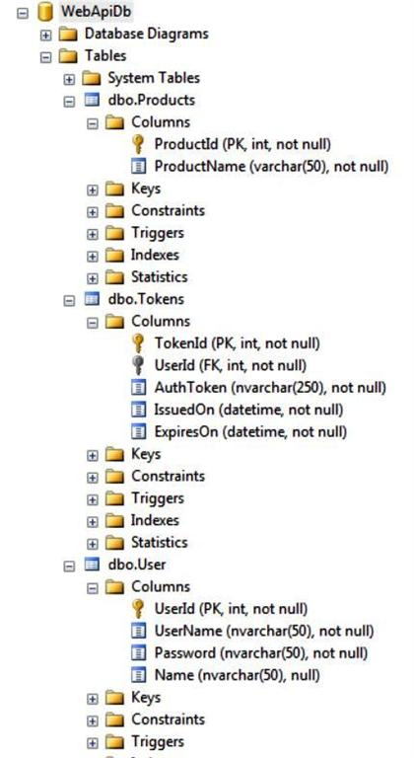

**Web API project**

Open your Visual Studio. I am using Visual Studio 2010, you can use Visual Studio version 2010 or above.

**Step 1**

Create a new Project in your Visual Studio as in the following:

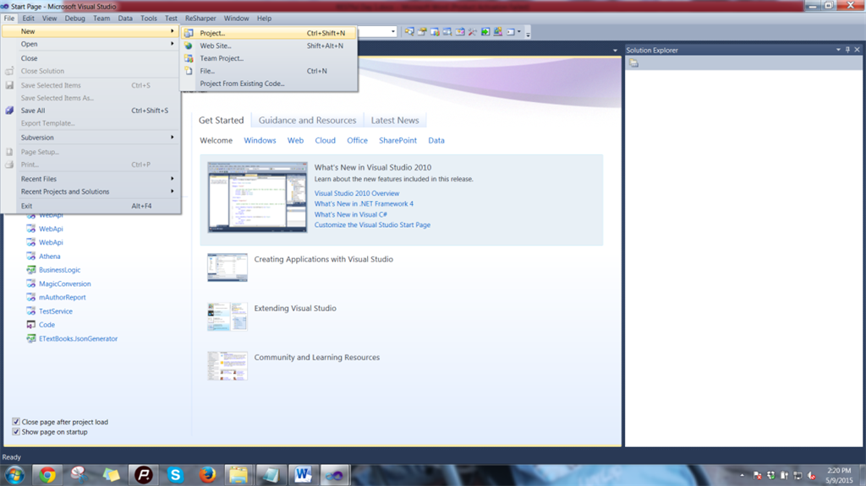

**Step 2**

Thereafter, choose to create an ASP.Net MVC 4 Web Application and provide it the name of your choice, I used **WebAPI**.

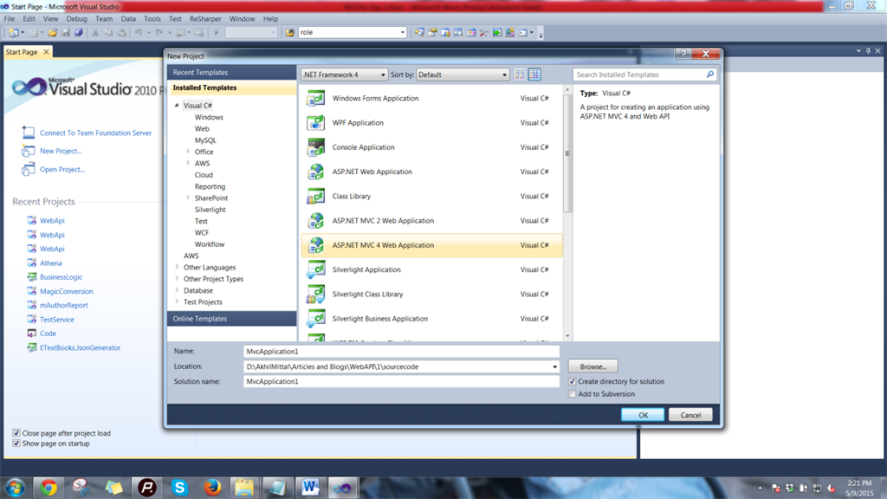

**Step 3**

Out of various type of project templates shown to you, choose Web API project as in the following:

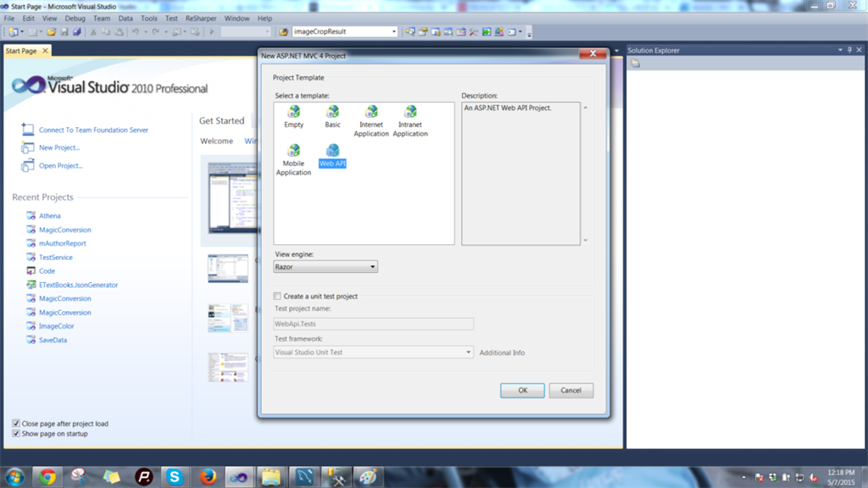

Once done, you'll get a project structure like the one shown below, with a default Home and Values controller.

You can choose to delete this ValuesController, since we'll be using our own controller to learn.

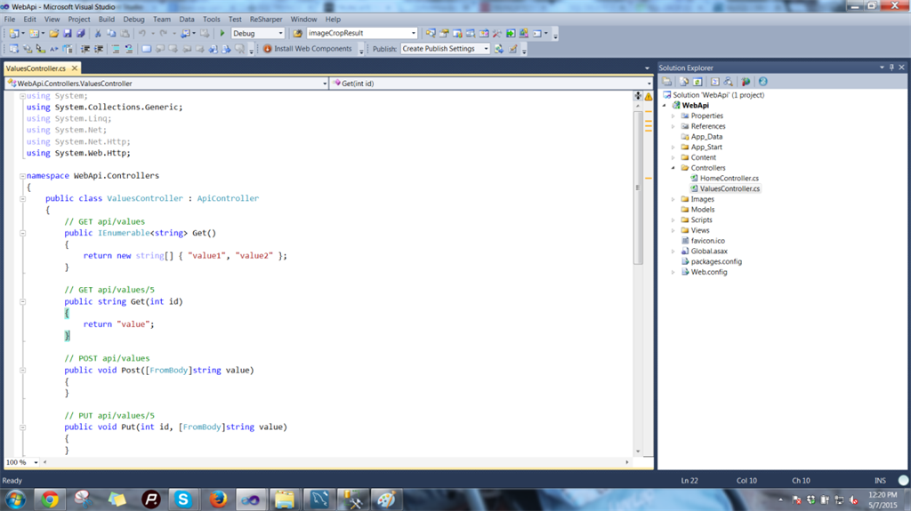

**Setup Data Access Layer**

Let's setup or data access layer first. We'll be using Entity Framework 5.0 to talk to the database. We'll use the Generic Repository Pattern and Unit of Work pattern to standardize our layer.

Let's have a look at the standard definition of Entity Framework given by Microsoft:

*“The Microsoft ADO.NET Entity Framework is an Object/Relational Mapping (ORM) framework that enables developers to work with relational data as domain-specific objects, eliminating the need for most of the data access plumbing code that developers usually need to write. Using the Entity Framework, developers issue queries using LINQ, then retrieve and manipulate data as strongly typed objects. The Entity Framework's ORM implementation provides services like change tracking, identity resolution, lazy loading and query translation so that developers can focus on their application-specific business logic rather than the data access fundamentals.”*

In simple language, Entity Framework is an Object/Relational Mapping (ORM) framework. It is an enhancement to ADO.NET, an upper layer to ADO.NET that gives developers an automated mechanism for accessing and storing the data in the database.

**Step 1**

Create a new class library in your Visual Studio and name it DataModel as shown below:

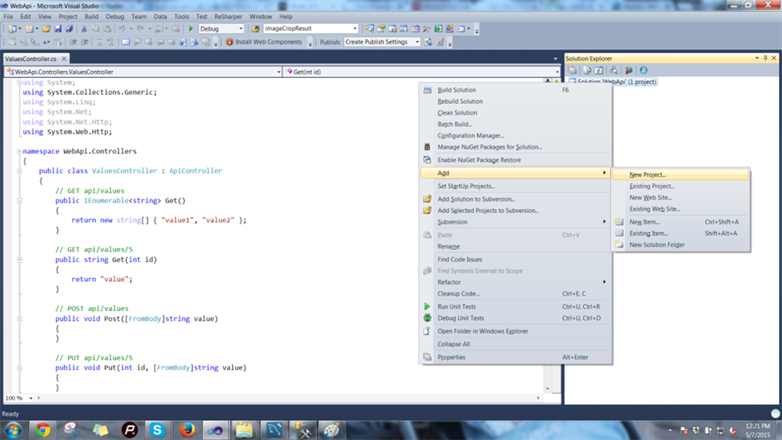

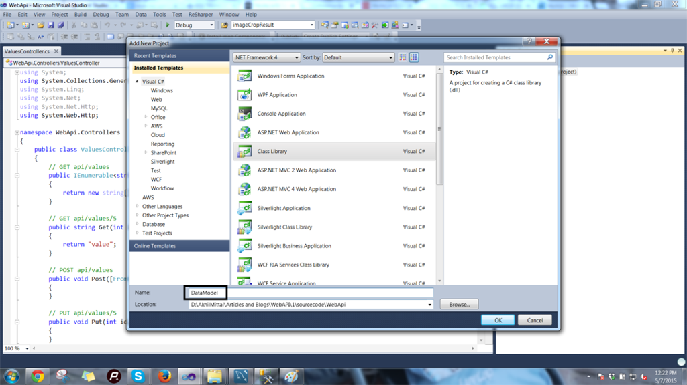

**Step 2**

In the same way, create one more project, again a class library, and call it BusinessEntities as in the following:

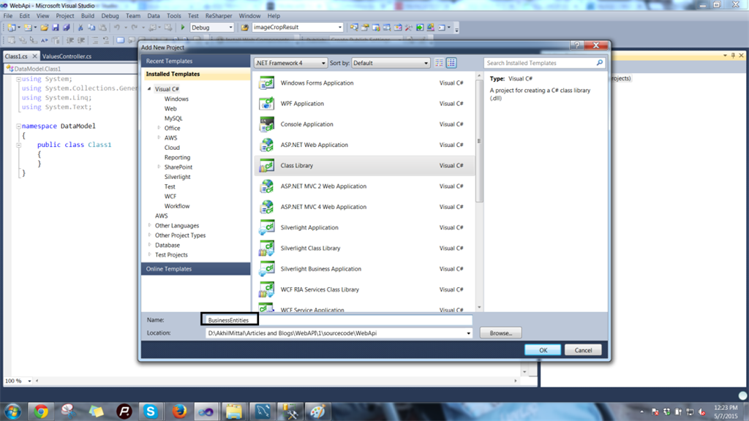

I'll explain the use of this class library soon.

**Step 3**

Move on to your DataModel project. Right-click on it and add a new item in the list shown, choose ADO.Net Data Model and name it WebApiDataModel.edmx.

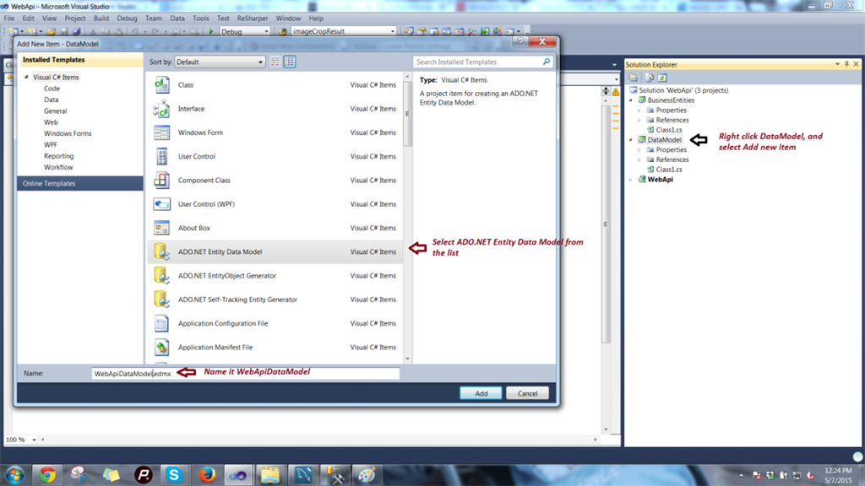

The file .edmx will contain the database information of our database that we created earlier, let's set this up.

You'll be presented a wizard as follows:

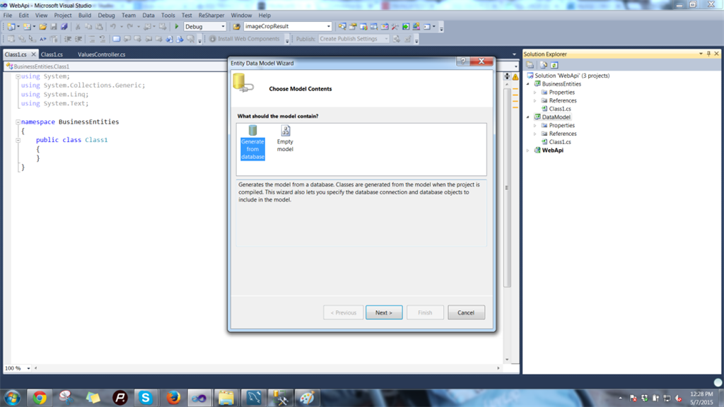

Choose generate from database. Choose Microsoft SQL Server as shown in the following image:

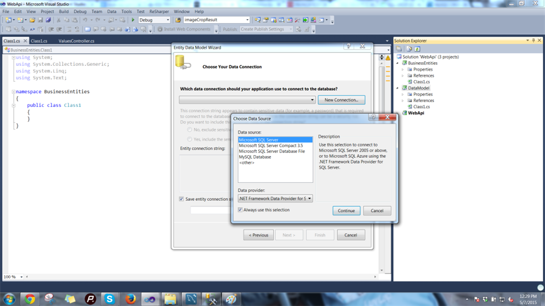

Click Continue, then provide the credentials for your database, in other words WebAPIdb and connect to it as in the following:

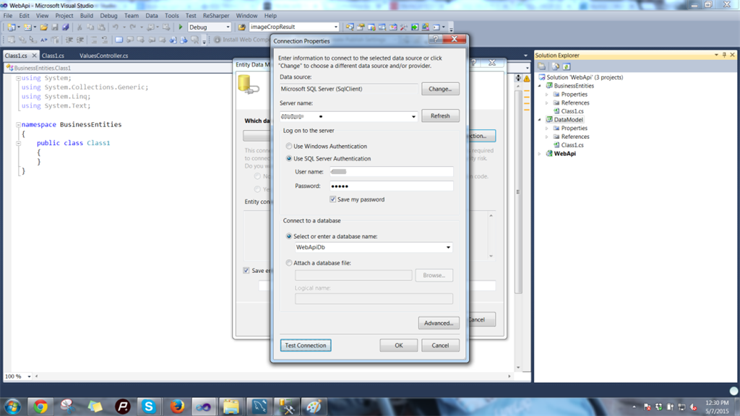

You'll get a screen showing the connection string of the database we chose as in the following:

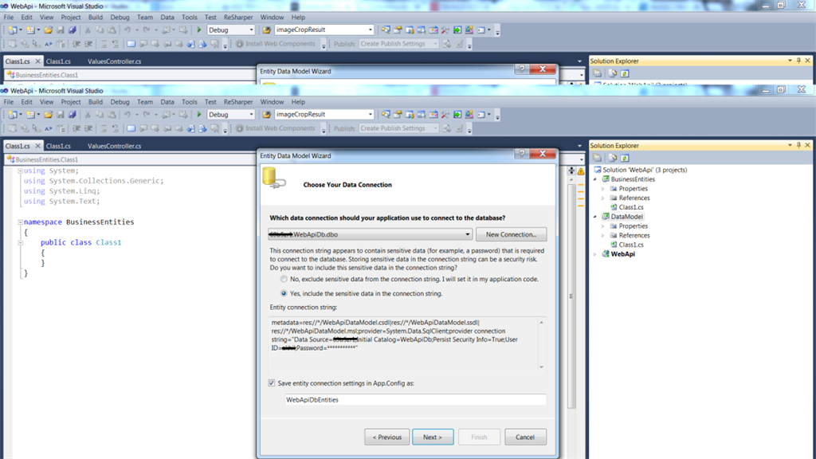

Provide the name of the connection string as WebApiDbEntities and click Next.

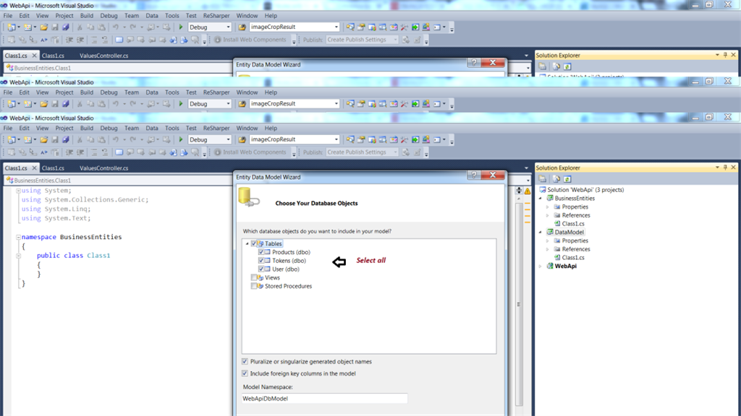

Choose all the database objects, check all the check boxes and provide a name for the model. I gave it the name WebApiDbModel.

Once you finish this wizard, you'll get the schema ready in your datamodel project as follows:

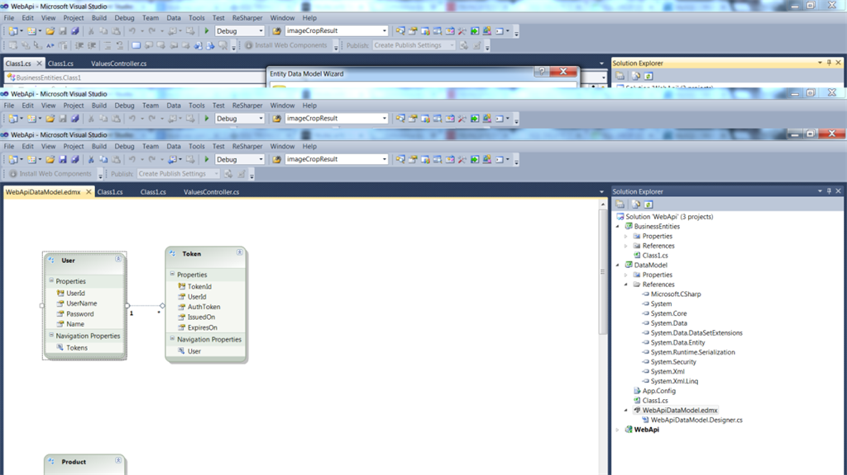

We've got our schema in-place using Entity Framework. But a bit of work remains. We need our data context class and entities through which we'll communicate with the database.

So, moving on to the next step.

**Step 4**

Click on Tools in Visual Studio and open the Extension Manager. We need to get a db context generator for our datamodel. We can also do it using the default code generation item by right-clicking in the edmx view and add a code generation item, but that will generate an object context class that is heavier than the db context. I want a lightweight db context class to be created, so we'll use the Extension Manager to add a package and then create a db context class.

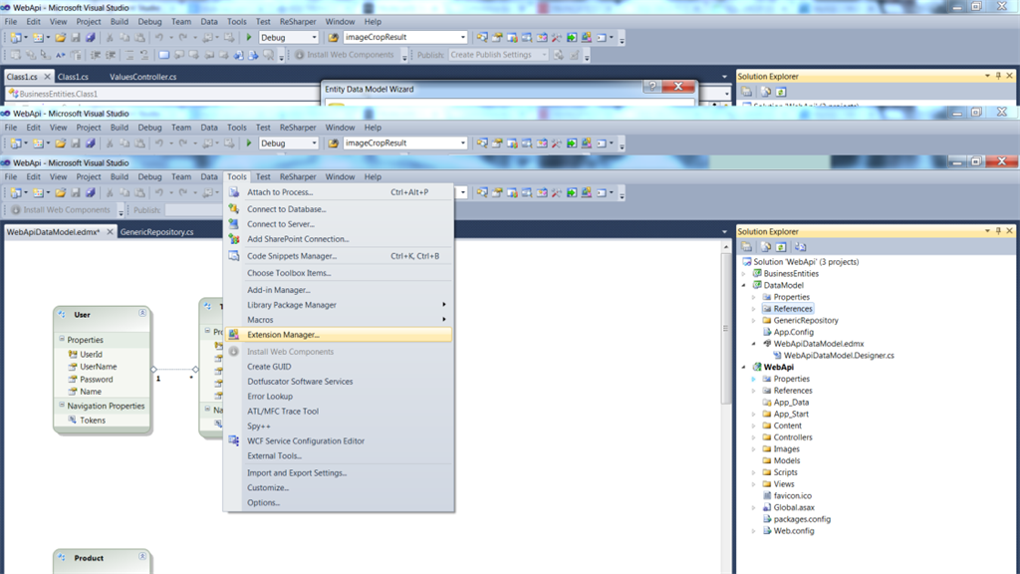

Search for Entity Framework Db context generator in the online gallery and select the one for EF 5.x as in the following:

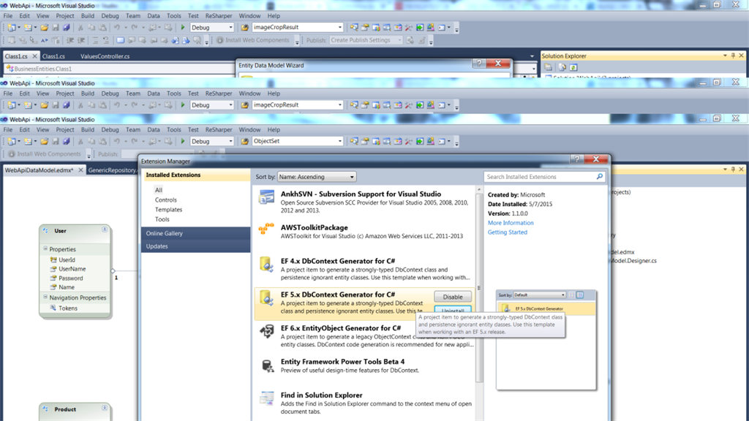

I guess you need to restart Visual Studio to get that into your templates.

**Step 5**

Now right-click in the .edmx file schema designer and choose “Run Custom Tool”

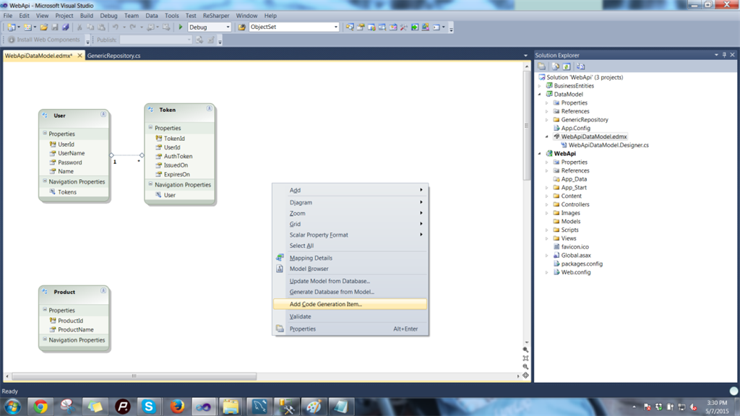

**Step 6**

After this we'll get the db context class and its properties. This class is responsible for all database transactions that we need to do, so our structure looks as shown below.

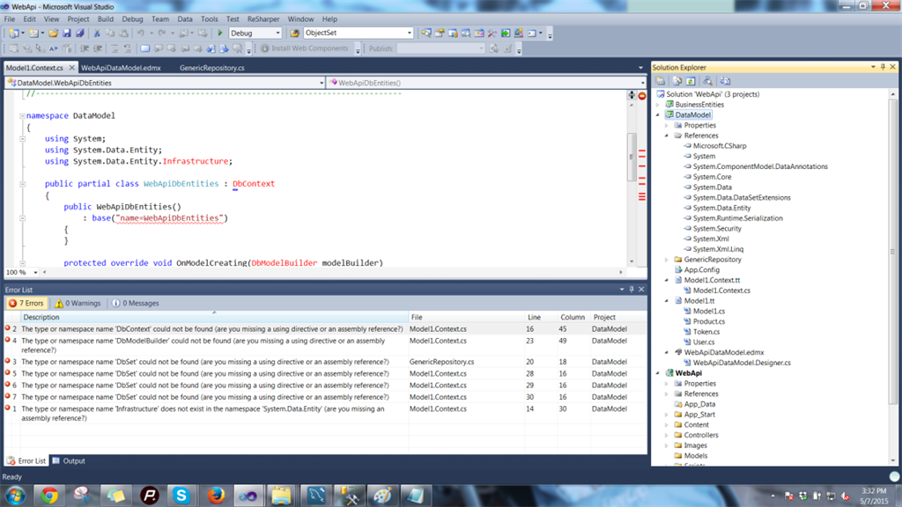

Wow, we ended up with errors. But we got our db context class and our entity models. You can see them in our DataModel project. Errors? Nothing to worry about , it's just we did not reference Entity Framework in our project. We'll do it the right away.

**Step 7**

Install EntityFramework NuGet package v. 6.2 for WebApi and DataModel projects. Copy connection string from App.config into web.config.

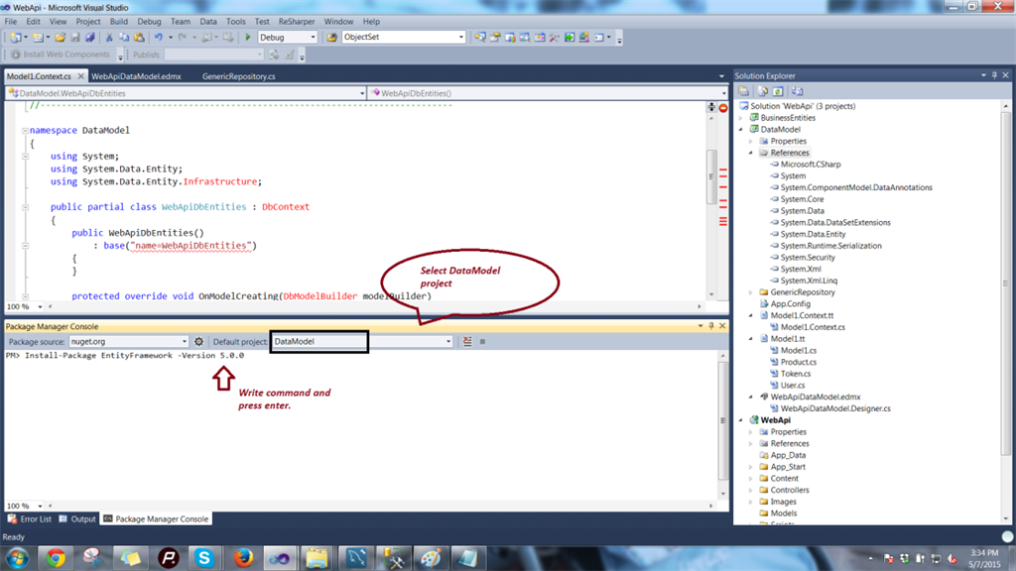

Rebuild. And all the errors become resolved.

**Generic Repository and Unit of Work**

You can read about the Repository Pattern and creating a repository in detail from my article:

[Repository Pattern in MVC3 Application With Entity Framework: Part 5](http://www.c-sharpcorner.com/UploadFile/1492b1/repository-pattern-in-mvc3-application-with-entity-framework/)

Just to list the benefits of the Repository Pattern:

* It centralizes the data logic or Web service access logic.
* It provides a substitution point for the unit tests.
* It provides a flexible architecture that can be adapted as the overall design of the application evolves.

We'll create a generic repository that works for all our entities. Creating repositories for each and every entity may result in lots of duplicate code in large projects. For creating a Generic Repository you can follow:

[Generic Repository Pattern in MVC3 Application With Entity Framework: Part 6](http://www.c-sharpcorner.com/UploadFile/1492b1/generic-repository-pattern-in-mvc3-application-with-entity-f/)

**Step 1**

Add a folder named GenericRepository to the DataModel project and to that folder add a class named Generic Repository. Add the following code to that class that serves as a template-based generic code for all the entities that will interact with the databse as in the following:

1. #region Using Namespaces...
3. **using** System;
4. **using** System.Collections.Generic;
5. **using** System.Data;
6. **using** System.Data.Entity;
7. **using** System.Linq;
9. #endregion
11. **namespace** DataModel.GenericRepository
12. {
13. /// <summary>
14. /// Generic Repository class for Entity Operations
15. /// </summary>
16. /// <typeparam name="TEntity"></typeparam>
17. **public** **class** GenericRepository<TEntity> where TEntity : **class**
18. {
19. #region Private member variables...
20. **internal** WebApiDbEntities Context;
21. **internal** DbSet<TEntity> DbSet;
22. #endregion
24. #region Public Constructor...
25. /// <summary>
26. /// Public Constructor,initializes privately declared local variables.
27. /// </summary>
28. /// <param name="context"></param>
29. **public** GenericRepository(WebApiDbEntities context)
30. {
31. **this**.Context = context;
32. **this**.DbSet = context.Set<TEntity>();
33. }
34. #endregion
36. #region Public member methods...
38. /// <summary>
39. /// generic Get method for Entities
40. /// </summary>
41. /// <returns></returns>
42. **public** **virtual** IEnumerable<TEntity> Get()
43. {
44. IQueryable<TEntity> query = DbSet;
45. **return** query.ToList();
46. }
48. /// <summary>
49. /// Generic get method on the basis of id for Entities.
50. /// </summary>
51. /// <param name="id"></param>
52. /// <returns></returns>
53. **public** **virtual** TEntity GetByID(**object** id)
54. {
55. **return** DbSet.Find(id);
56. }
58. /// <summary>
59. /// generic Insert method for the entities
60. /// </summary>
61. /// <param name="entity"></param>
62. **public** **virtual** **void** Insert(TEntity entity)
63. {
64. DbSet.Add(entity);
65. }
67. /// <summary>
68. /// Generic Delete method for the entities
69. /// </summary>
70. /// <param name="id"></param>
71. **public** **virtual** **void** Delete(**object** id)
72. {
73. TEntity entityToDelete = DbSet.Find(id);
74. Delete(entityToDelete);
75. }
77. /// <summary>
78. /// Generic Delete method for the entities
79. /// </summary>
80. /// <param name="entityToDelete"></param>
81. **public** **virtual** **void** Delete(TEntity entityToDelete)
82. {
83. **if** (Context.Entry(entityToDelete).State == EntityState.Detached)
84. {
85. DbSet.Attach(entityToDelete);
86. }
87. DbSet.Remove(entityToDelete);
88. }
90. /// <summary>
91. /// Generic update method for the entities
92. /// </summary>
93. /// <param name="entityToUpdate"></param>
94. **public** **virtual** **void** Update(TEntity entityToUpdate)
95. {
96. DbSet.Attach(entityToUpdate);
97. Context.Entry(entityToUpdate).State = EntityState.Modified;
98. }
100. /// <summary>
101. /// generic method to get many record on the basis of a condition.
102. /// </summary>
103. /// <param name="where"></param>
104. /// <returns></returns>
105. **public** **virtual** IEnumerable<TEntity> GetMany(Func<TEntity, **bool**> where)
106. {
107. **return** DbSet.Where(where).ToList();
108. }
110. /// <summary>
111. /// generic method to get many record on the basis of a condition but query able.
112. /// </summary>
113. /// <param name="where"></param>
114. /// <returns></returns>
115. **public** **virtual** IQueryable<TEntity> GetManyQueryable(Func<TEntity, **bool**> where)
116. {
117. **return** DbSet.Where(where).AsQueryable();
118. }
120. /// <summary>
121. /// generic get method , fetches data for the entities on the basis of condition.
122. /// </summary>
123. /// <param name="where"></param>
124. /// <returns></returns>
125. **public** TEntity Get(Func<TEntity, Boolean> where)
126. {
127. **return** DbSet.Where(where).FirstOrDefault<TEntity>();
128. }
130. /// <summary>
131. /// generic delete method , deletes data for the entities on the basis of condition.
132. /// </summary>
133. /// <param name="where"></param>
134. /// <returns></returns>
135. **public** **void** Delete(Func<TEntity, Boolean> where)
136. {
137. IQueryable<TEntity> objects = DbSet.Where<TEntity>(where).AsQueryable();
138. **foreach** (TEntity obj **in** objects)
139. DbSet.Remove(obj);
140. }
142. /// <summary>
143. /// generic method to fetch all the records from db
144. /// </summary>
145. /// <returns></returns>
146. **public** **virtual** IEnumerable<TEntity> GetAll()
147. {
148. **return** DbSet.ToList();
149. }
151. /// <summary>
152. /// Inclue multiple
153. /// </summary>
154. /// <param name="predicate"></param>
155. /// <param name="include"></param>
156. /// <returns></returns>
157. **public** IQueryable<TEntity> GetWithInclude(System.Linq.Expressions.Expression<Func<TEntity, **bool**>> predicate, **params** **string**[] include)
158. {
159. IQueryable<TEntity> query = **this**.DbSet;
160. query = include.Aggregate(query, (current, inc) => current.Include(inc));
161. **return** query.Where(predicate);
162. }
164. /// <summary>
165. /// Generic method to check if entity exists
166. /// </summary>
167. /// <param name="primaryKey"></param>
168. /// <returns></returns>
169. **public** **bool** Exists(**object** primaryKey)
170. {
171. **return** DbSet.Find(primaryKey) != **null**;
172. }
174. /// <summary>
175. /// Gets a single record by the specified criteria (usually the unique identifier)
176. /// </summary>
177. /// <param name="predicate">Criteria to match on</param>
178. /// <returns>A single record that matches the specified criteria</returns>
179. **public** TEntity GetSingle(Func<TEntity, **bool**> predicate)
180. {
181. **return** DbSet.Single<TEntity>(predicate);
182. }
184. /// <summary>
185. /// The first record matching the specified criteria
186. /// </summary>
187. /// <param name="predicate">Criteria to match on</param>
188. /// <returns>A single record containing the first record matching the specified criteria</returns>
189. **public** TEntity GetFirst(Func<TEntity, **bool**> predicate)
190. {
191. **return** DbSet.First<TEntity>(predicate);
192. }

195. #endregion
196. }
197. }

**Unit of Work**

Again, I'll not explain in detail what Unit of Work is. You can Google about the theory or follow my existing article on [MVC with Unit of Work](http://www.c-sharpcorner.com/UploadFile/1492b1/generic-repository-pattern-in-mvc3-application-with-entity-f/).

To give a heads up, again from my existing article, the important responsibilities of Unit of Work are the following:

* To manage transactions.
* To order the database inserts, deletes and updates.
* To prevent duplicate updates. Inside a single usage of a Unit of Work object, various parts of the code may mark the same Invoice object as changed, but the Unit of Work class will only issue a single UPDATE command to the database.

The value of using a Unit of Work pattern is to free the rest of our code from these concerns so that you can otherwise concentrate on the business logic.

**Step 1**

Create a folder named UnitOfWork and add a class to that folder named UnitOfWork.cs.

Add GenericRepository properties for all the three entities that we got. The class also implements an IDisposable interface and it's method Dispose to free up connections and objects. The class will be as follows.

1. #region Using Namespaces...
3. **using** System;
4. **using** System.Collections.Generic;
5. **using** System.Diagnostics;
6. **using** System.Data.Entity.Validation;
7. **using** DataModel.GenericRepository;
9. #endregion
11. **namespace** DataModel.UnitOfWork
12. {
13. /// <summary>
14. /// Unit of Work class responsible for DB transactions
15. /// </summary>
16. **public** **class** UnitOfWork : IDisposable
17. {
18. #region Private member variables...
20. **private** WebApiDbEntities _context = **null**;
21. **private** GenericRepository<User> _userRepository;
22. **private** GenericRepository<Product> _productRepository;
23. **private** GenericRepository<Token> _tokenRepository;
24. #endregion
26. **public** UnitOfWork()
27. {
28. _context = **new** WebApiDbEntities();
29. }
31. #region Public Repository Creation properties...
33. /// <summary>
34. /// Get/Set Property for product repository.
35. /// </summary>
36. **public** GenericRepository<Product> ProductRepository
37. {
38. **get**
39. {
40. **if** (**this**._productRepository == **null**)
41. **this**._productRepository = **new** GenericRepository<Product>(_context);
42. **return** _productRepository;
43. }
44. }
46. /// <summary>
47. /// Get/Set Property for user repository.
48. /// </summary>
49. **public** GenericRepository<User> UserRepository
50. {
51. **get**
52. {
53. **if** (**this**._userRepository == **null**)
54. **this**._userRepository = **new** GenericRepository<User>(_context);
55. **return** _userRepository;
56. }
57. }
59. /// <summary>
60. /// Get/Set Property for token repository.
61. /// </summary>
62. **public** GenericRepository<Token> TokenRepository
63. {
64. **get**
65. {
66. **if** (**this**._tokenRepository == **null**)
67. **this**._tokenRepository = **new** GenericRepository<Token>(_context);
68. **return** _tokenRepository;
69. }
70. }
71. #endregion
73. #region Public member methods...
74. /// <summary>
75. /// Save method.
76. /// </summary>
77. **public** **void** Save()
78. {
79. **try**
80. {
81. _context.SaveChanges();
82. }
83. **catch** (DbEntityValidationException e)
84. {
86. var outputLines = **new** List<**string**>();
87. **foreach** (var eve **in** e.EntityValidationErrors)
88. {
89. outputLines.Add(**string**.Format("{0}: Entity of type \"{1}\" in state \"{2}\" has the following validation errors:", DateTime.Now, eve.Entry.Entity.GetType().Name, eve.Entry.State));
90. **foreach** (var ve **in** eve.ValidationErrors)
91. {
92. outputLines.Add(**string**.Format("- Property: \"{0}\", Error: \"{1}\"", ve.PropertyName, ve.ErrorMessage));
93. }
94. }
95. System.IO.File.AppendAllLines(@"C:\errors.txt", outputLines);
97. **throw** e;
98. }
100. }
102. #endregion
104. #region Implementing IDiosposable...
106. #region private dispose variable declaration...
107. **private** **bool** disposed = **false**;
108. #endregion
110. /// <summary>
111. /// Protected Virtual Dispose method
112. /// </summary>
113. /// <param name="disposing"></param>
114. **protected** **virtual** **void** Dispose(**bool** disposing)
115. {
116. **if** (!**this**.disposed)
117. {
118. **if** (disposing)
119. {
120. Debug.WriteLine("UnitOfWork is being disposed");
121. _context.Dispose();
122. }
123. }
124. **this**.disposed = **true**;
125. }
127. /// <summary>
128. /// Dispose method
129. /// </summary>
130. **public** **void** Dispose()
131. {
132. Dispose(**true**);
133. GC.SuppressFinalize(**this**);
134. }
135. #endregion
136. }
137. }

Now we have completely set up our data access layer and our project structure looks as shown below.

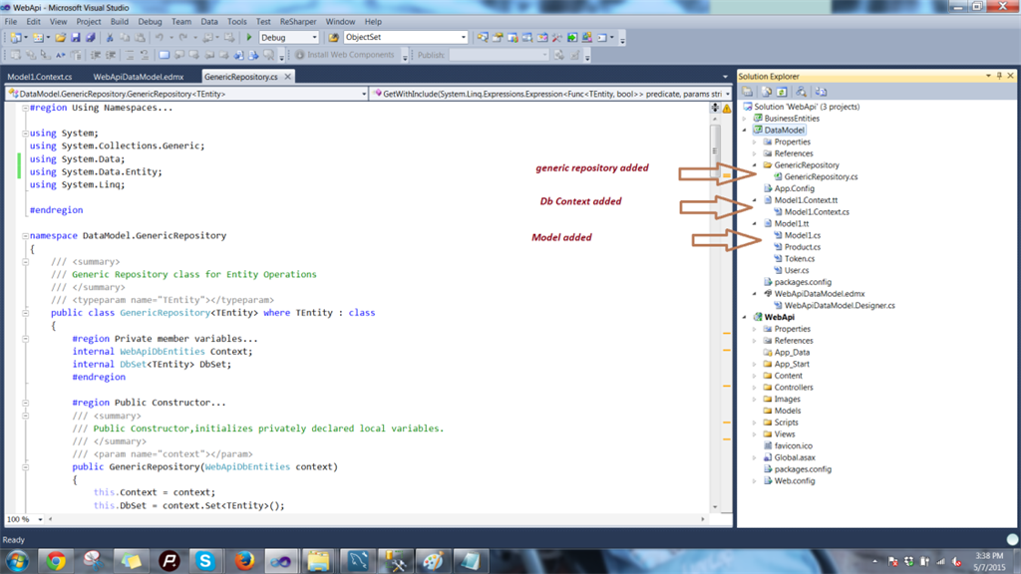

**Setup Business Entities**

Remember, we created a business entities project. You may wonder, since we already have database entities to interact with the database, why do we need Business Entities? The answer is as simple as, we are trying to follow a proper structure of communication and one would never want to expose the database entities to the end client, in our case the Web API, it involves a lot of risk. Hackers may manipulate the details and get access to your database. Instead, we'll use database entities in our business logic layer and use Business Entities as transfer objects to communicate between the business logic and the Web API project. So business entities may have different names, but their properties remain the same as database entities. In our case we'll add same-named business entity classes appended with the word “Entity” in our BusinessEntity project. So we'll end up having the following three classes:

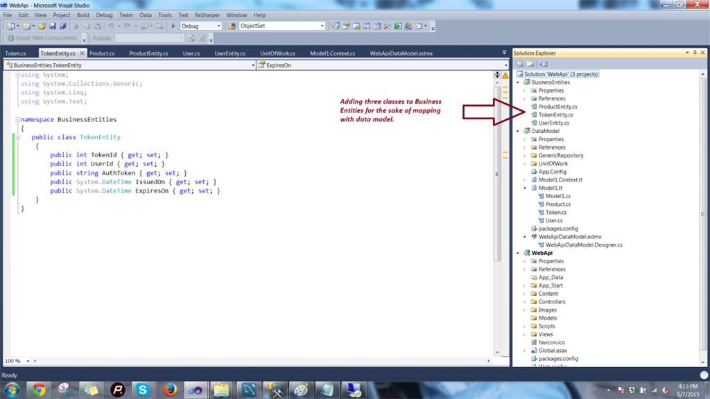

**Product Entity**

1. **public** **class** ProductEntity
2. {
3. **public** **int** ProductId { **get**; **set**; }
4. **public** **string** ProductName { **get**; **set**; }
5. }

**Token entity**

1. **public** **class** TokenEntity
2. {
3. **public** **int** TokenId { **get**; **set**; }
4. **public** **int** UserId { **get**; **set**; }
5. **public** **string** AuthToken { **get**; **set**; }
6. **public** System.DateTime IssuedOn { **get**; **set**; }
7. **public** System.DateTime ExpiresOn { **get**; **set**; }
8. }

**User Entity**

1. **public** **class** UserEntity
2. {
3. **public** **int** UserId { **get**; **set**; }
4. **public** **string** UserName { **get**; **set**; }
5. **public** **string** word { **get**; **set**; }
6. **public** **string** Name { **get**; **set**; }
7. }

**Setup Business Services Project**

Add a new class library to the solution named BusinessServices. This layer will act as our business logic layer. Note that, we can use our API controllers to write the business logic, but I am trying to segregate my business logic in an extra layer so that if in the future I want to use WCF, MVC, ASP.Net Web Pages or any other application as my presentation layer then I can easily integrate my Business logic layer into it.

We'll make this layer testable, so we need to create an interface and in it declare CRUD operations to be performed over a product table. Before we proceed, add a reference for the BusinessEntities project and DataModel project to this newly-created project.

**Step 1**

Create an interface named IProductServices and add the following code to it for CRUD operations methods.

1. **using** System.Collections.Generic;
2. **using** BusinessEntities;
4. **namespace** BusinessServices
5. {
6. /// <summary>
7. /// Product Service Contract
8. /// </summary>
9. **public** **interface** IProductServices
10. {
11. ProductEntity GetProductById(**int** productId);
12. IEnumerable<ProductEntity> GetAllProducts();
13. **int** CreateProduct(ProductEntity productEntity);
14. **bool** UpdateProduct(**int** productId,ProductEntity productEntity);
15. **bool** DeleteProduct(**int** productId);
16. }
17. }

**Step 2**

Create a class to implement this interface. Name that class ProductServices.

The class contains a private variable of UnitOfWork and a constructor to initialize that variable as in the following:

1. **private** **readonly** UnitOfWork _unitOfWork;
3. /// <summary>
4. /// Public constructor.
5. /// </summary>
6. **public** ProductServices()
7. {
8. _unitOfWork = **new** UnitOfWork();
9. }

We have decided not to expose our db entities to the Web API project, so we need something to map the db entities data to my business entity classes. We'll make use of AutoMapper. You can read about AutoMapper in my [this article](http://www.c-sharpcorner.com/UploadFile/1492b1/crud-operations-using-automapper-in-mvc-application/).

**Step 3**

Just right-click the project then select Extension manager, search for AutoMapper in the online galary and add it to the BusinessServices project as in the following:

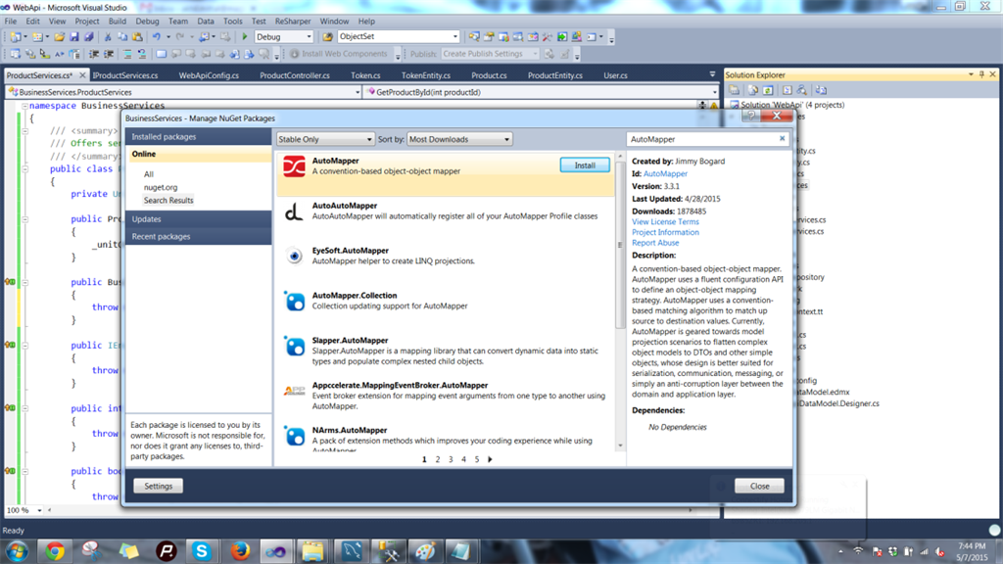

**Step 4**

Implement the following methods in the ProductServices class.

Add the following code to the class:

1. **using** System.Collections.Generic;
2. **using** System.Linq;
3. **using** System.Transactions;
4. **using** AutoMapper;
5. **using** BusinessEntities;
6. **using** DataModel;
7. **using** DataModel.UnitOfWork;
9. **namespace** BusinessServices
10. {
11. /// <summary>
12. /// Offers services for product specific CRUD operations
13. /// </summary>
14. **public** **class** ProductServices:IProductServices
15. {
16. **private** **readonly** UnitOfWork _unitOfWork;
18. /// <summary>
19. /// Public constructor.
20. /// </summary>
21. **public** ProductServices()
22. {
23. _unitOfWork = **new** UnitOfWork();
24. }
26. /// <summary>
27. /// Fetches product details by id
28. /// </summary>
29. /// <param name="productId"></param>
30. /// <returns></returns>
31. **public** BusinessEntities.ProductEntity GetProductById(**int** productId)
32. {
33. var product = _unitOfWork.ProductRepository.GetByID(productId);
34. **if** (product != **null**)
35. {
36. Mapper.CreateMap<Product, ProductEntity>();
37. var productModel = Mapper.Map<Product, ProductEntity>(product);
38. **return** productModel;
39. }
40. **return** **null**;
41. }
43. /// <summary>
44. /// Fetches all the products.
45. /// </summary>
46. /// <returns></returns>
47. **public** IEnumerable<BusinessEntities.ProductEntity> GetAllProducts()
48. {
49. var products = _unitOfWork.ProductRepository.GetAll().ToList();
50. **if** (products.Any())
51. {
52. Mapper.CreateMap<Product, ProductEntity>();
53. var productsModel = Mapper.Map<List<Product>, List<ProductEntity>>(products);
54. **return** productsModel;
55. }
56. **return** **null**;
57. }
59. /// <summary>
60. /// Creates a product
61. /// </summary>
62. /// <param name="productEntity"></param>
63. /// <returns></returns>
64. **public** **int** CreateProduct(BusinessEntities.ProductEntity productEntity)
65. {
66. **using** (var scope = **new** TransactionScope())
67. {
68. var product = **new** Product
69. {
70. ProductName = productEntity.ProductName
71. };
72. _unitOfWork.ProductRepository.Insert(product);
73. _unitOfWork.Save();
74. scope.Complete();
75. **return** product.ProductId;
76. }
77. }
79. /// <summary>
80. /// Updates a product
81. /// </summary>
82. /// <param name="productId"></param>
83. /// <param name="productEntity"></param>
84. /// <returns></returns>
85. **public** **bool** UpdateProduct(**int** productId, BusinessEntities.ProductEntity productEntity)
86. {
87. var success = **false**;
88. **if** (productEntity != **null**)
89. {
90. **using** (var scope = **new** TransactionScope())
91. {
92. var product = _unitOfWork.ProductRepository.GetByID(productId);
93. **if** (product != **null**)
94. {
95. product.ProductName = productEntity.ProductName;
96. _unitOfWork.ProductRepository.Update(product);
97. _unitOfWork.Save();
98. scope.Complete();
99. success = **true**;
100. }
101. }
102. }
103. **return** success;
104. }
106. /// <summary>
107. /// Deletes a particular product
108. /// </summary>
109. /// <param name="productId"></param>
110. /// <returns></returns>
111. **public** **bool** DeleteProduct(**int** productId)
112. {
113. var success = **false**;
114. **if** (productId > 0)
115. {
116. **using** (var scope = **new** TransactionScope())
117. {
118. var product = _unitOfWork.ProductRepository.GetByID(productId);
119. **if** (product != **null**)
120. {
122. _unitOfWork.ProductRepository.Delete(product);
123. _unitOfWork.Save();
124. scope.Complete();
125. success = **true**;
126. }
127. }
128. }
129. **return** success;
130. }
131. }
132. }

Let me explain the idea of the code. We have the following 5 methods:

1. To get a product by id (GetproductById): We call the repository to get the product by id. Id is a parameter from the calling method to that service method. It returns the product entity from the database. Note that it will not return the exact db entity, instead we'll map it with our business entity using AutoMapper and return it to the calling method.
   1. /// <summary>
   2. /// Fetches product details by id
   3. /// </summary>
   4. /// <param name="productId"></param>
   5. /// <returns></returns>
   6. **public** BusinessEntities.ProductEntity GetProductById(**int** productId)
   7. {
   8. var product = _unitOfWork.ProductRepository.GetByID(productId);
   9. **if** (product != **null**)
   10. {
   11. Mapper.CreateMap<Product, ProductEntity>();
   12. var productModel = Mapper.Map<Product, ProductEntity>(product);
   13. **return** productModel;
   14. }
   15. **return** **null**;
   16. }
2. Get all products from the database (GetAllProducts): This method returns all the products residing in the database, again we use AutoMapper to map the list and return it.
   1. /// <summary>
   2. /// Fetches all the products.
   3. /// </summary>
   4. /// <returns></returns>
   5. **public** IEnumerable<BusinessEntities.ProductEntity> GetAllProducts()
   6. {
   7. var products = _unitOfWork.ProductRepository.GetAll().ToList();
   8. **if** (products.Any())
   9. {
   10. Mapper.CreateMap<Product, ProductEntity>();
   11. var productsModel = Mapper.Map<List<Product>, List<ProductEntity>>(products);
   12. **return** productsModel;
   13. }
   14. **return** **null**;
   15. }
3. Create a new product (CreateProduct): This method takes the product's BusinessEntity as an argument and creates a new object of an actual database entity and inserts it using a unit of work.
   1. /// <summary>
   2. /// Creates a product
   3. /// </summary>
   4. /// <param name="productEntity"></param>
   5. /// <returns></returns>
   6. **public** **int** CreateProduct(BusinessEntities.ProductEntity productEntity)
   7. {
   8. **using** (var scope = **new** TransactionScope())
   9. {
   10. var product = **new** Product
   11. {
   12. ProductName = productEntity.ProductName
   13. };
   14. _unitOfWork.ProductRepository.Insert(product);
   15. _unitOfWork.Save();
   16. scope.Complete();
   17. **return** product.ProductId;
   18. }
   19. }

I guess you can now write update and delete methods. So the following is the code for the complete class.

1. **using** System.Collections.Generic;
2. **using** System.Linq;
3. **using** System.Transactions;
4. **using** AutoMapper;
5. **using** BusinessEntities;
6. **using** DataModel;
7. **using** DataModel.UnitOfWork;
9. **namespace** BusinessServices
10. {
11. /// <summary>
12. /// Offers services for product specific CRUD operations
13. /// </summary>
14. **public** **class** ProductServices:IProductServices
15. {
16. **private** **readonly** UnitOfWork _unitOfWork;
18. /// <summary>
19. /// Public constructor.
20. /// </summary>
21. **public** ProductServices()
22. {
23. _unitOfWork = **new** UnitOfWork();
24. }
26. /// <summary>
27. /// Fetches product details by id
28. /// </summary>
29. /// <param name="productId"></param>
30. /// <returns></returns>
31. **public** BusinessEntities.ProductEntity GetProductById(**int** productId)
32. {
33. var product = _unitOfWork.ProductRepository.GetByID(productId);
34. **if** (product != **null**)
35. {
36. Mapper.CreateMap<Product, ProductEntity>();
37. var productModel = Mapper.Map<Product, ProductEntity>(product);
38. **return** productModel;
39. }
40. **return** **null**;
41. }
43. /// <summary>
44. /// Fetches all the products.
45. /// </summary>
46. /// <returns></returns>
47. **public** IEnumerable<BusinessEntities.ProductEntity> GetAllProducts()
48. {
49. var products = _unitOfWork.ProductRepository.GetAll().ToList();
50. **if** (products.Any())
51. {
52. Mapper.CreateMap<Product, ProductEntity>();
53. var productsModel = Mapper.Map<List<Product>, List<ProductEntity>>(products);
54. **return** productsModel;
55. }
56. **return** **null**;
57. }
59. /// <summary>
60. /// Creates a product
61. /// </summary>
62. /// <param name="productEntity"></param>
63. /// <returns></returns>
64. **public** **int** CreateProduct(BusinessEntities.ProductEntity productEntity)
65. {
66. **using** (var scope = **new** TransactionScope())
67. {
68. var product = **new** Product
69. {
70. ProductName = productEntity.ProductName
71. };
72. _unitOfWork.ProductRepository.Insert(product);
73. _unitOfWork.Save();
74. scope.Complete();
75. **return** product.ProductId;
76. }
77. }
79. /// <summary>
80. /// Updates a product
81. /// </summary>
82. /// <param name="productId"></param>
83. /// <param name="productEntity"></param>
84. /// <returns></returns>
85. **public** **bool** UpdateProduct(**int** productId, BusinessEntities.ProductEntity productEntity)
86. {
87. var success = **false**;
88. **if** (productEntity != **null**)
89. {
90. **using** (var scope = **new** TransactionScope())
91. {
92. var product = _unitOfWork.ProductRepository.GetByID(productId);
93. **if** (product != **null**)
94. {
95. product.ProductName = productEntity.ProductName;
96. _unitOfWork.ProductRepository.Update(product);
97. _unitOfWork.Save();
98. scope.Complete();
99. success = **true**;
100. }
101. }
102. }
103. **return** success;
104. }
106. /// <summary>
107. /// Deletes a particular product
108. /// </summary>
109. /// <param name="productId"></param>
110. /// <returns></returns>
111. **public** **bool** DeleteProduct(**int** productId)
112. {
113. var success = **false**;
114. **if** (productId > 0)
115. {
116. **using** (var scope = **new** TransactionScope())
117. {
118. var product = _unitOfWork.ProductRepository.GetByID(productId);
119. **if** (product != **null**)
120. {
122. _unitOfWork.ProductRepository.Delete(product);
123. _unitOfWork.Save();
124. scope.Complete();
125. success = **true**;
126. }
127. }
128. }
129. **return** success;
130. }
131. }
132. }

The job is niw done at the business service level. Let's move on to the API controller to call these methods.

**Setup WebAPI project**

**Step 1**

Just add references for BusinessEntity and BusinessService to the WebAPI project, our architecture becomes like the following:

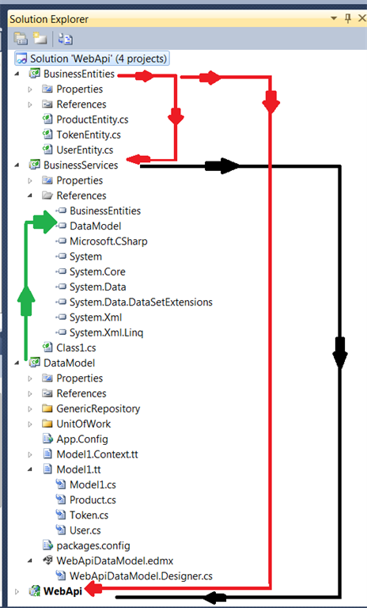

**Step 2**

Add a new WebAPI controller to the Controller folder. Right-click the Controller folder and add a new controller.

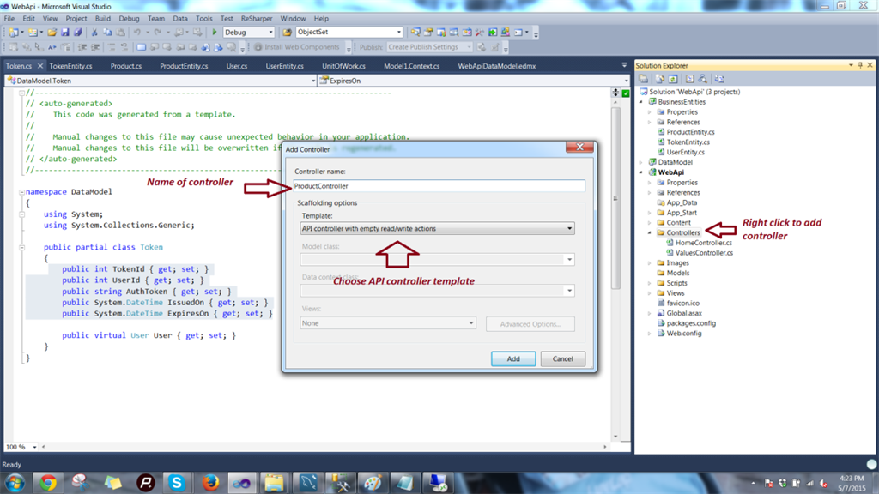

We get a controller as follows:

1. **using** System;
2. **using** System.Collections.Generic;
3. **using** System.Linq;
4. **using** System.Net;
5. **using** System.Net.Http;
6. **using** System.Web.Http;
8. **namespace** WebApi.Controllers
9. {
10. **public** **class** ProductController : ApiController
11. {
12. // GET api/product
13. **public** IEnumerable<**string**> Get()
14. {
15. **return** **new** **string**[] { "value1", "value2" };
16. }
18. // GET api/product/5
19. **public** **string** Get(**int** id)
20. {
21. **return** "value";
22. }
24. // POST api/product
25. **public** **void** Post([FromBody]**string** value)
26. {
27. }
29. // PUT api/product/5
30. **public** **void** Put(**int** id, [FromBody]**string** value)
31. {
32. }
34. // DELETE api/product/5
35. **public** **void** Delete(**int** id)
36. {
37. }
38. }
39. }

We get HTTP VERBS as method names. The Web API is smart enough to recognize a request with the name of the VERB itself. In our case we are doing CRUD operations, so we don't need to change the names of the method, we just needed this. We only need to write the calling logic inside these methods. In my future articles of the series, we will work out how to define new routes and provide method names of our choice with those routes.

**Step 3**

Add logic to call Business Service methods. Just make an object of the Business Service and call its respective methods, our Controller class becomes like:

1. **using** System.Collections.Generic;
2. **using** System.Linq;
3. **using** System.Net;
4. **using** System.Net.Http;
5. **using** System.Web.Http;
6. **using** BusinessEntities;
7. **using** BusinessServices;
9. **namespace** WebApi.Controllers
10. {
11. **public** **class** ProductController : ApiController
12. {
14. **private** **readonly** IProductServices _productServices;
16. #region Public Constructor
18. /// <summary>
19. /// Public constructor to initialize product service instance
20. /// </summary>
21. **public** ProductController()
22. {
23. _productServices =**new** ProductServices();
24. }
26. #endregion
28. // GET api/product
29. **public** HttpResponseMessage Get()
30. {
31. var products = _productServices.GetAllProducts();
32. if(products!=null)
33. {
34. var productEntities = products **as** List<ProductEntity> ?? products.ToList();
35. **if** (productEntities.Any())
36. **return** Request.CreateResponse(HttpStatusCode.OK, productEntities);
37. }
38. **return** Request.CreateErrorResponse(HttpStatusCode.NotFound, "Products not found");
39. }
41. // GET api/product/5
42. **public** HttpResponseMessage Get(**int** id)
43. {
44. var product = _productServices.GetProductById(id);
45. **if** (product != **null**)
46. **return** Request.CreateResponse(HttpStatusCode.OK, product);
47. **return** Request.CreateErrorResponse(HttpStatusCode.NotFound, "No product found for this id");
48. }
50. // POST api/product
51. **public** **int** Post([FromBody] ProductEntity productEntity)
52. {
53. **return** _productServices.CreateProduct(productEntity);
54. }
56. // PUT api/product/5
57. **public** **bool** Put(**int** id, [FromBody]ProductEntity productEntity)
58. {
59. **if** (id  > 0)
60. {
61. **return** _productServices.UpdateProduct(id, productEntity);
62. }
63. **return** **false**;
64. }
66. // DELETE api/product/5
67. **public** **bool** Delete(**int** id)
68. {
69. **if** (id > 0)
70. **return** _productServices.DeleteProduct(id);
71. **return** **false**;
72. }
73. }
74. }

Just run the application and we will get:

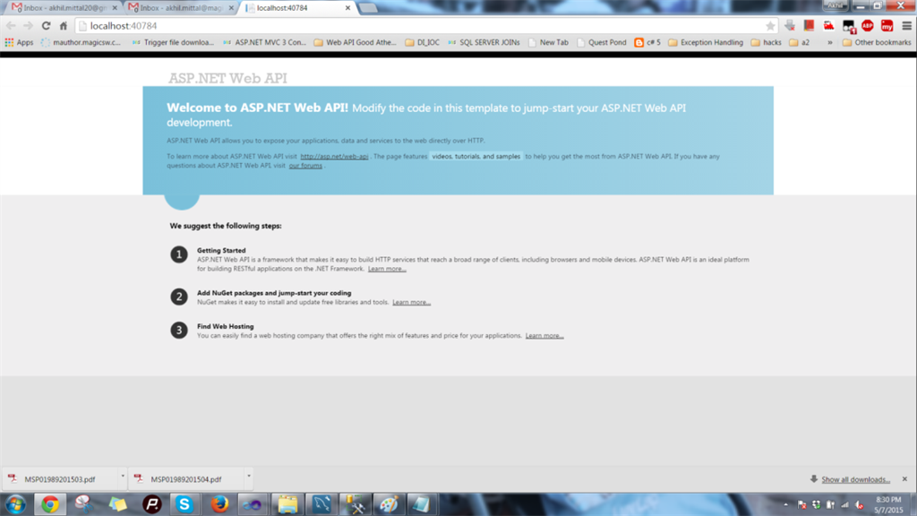

But now how do we test our API? We don't have a client. Guys, we'll not be writing a client now to test it. We'll add a package that will do all the work.

Just go to Manage Nuget Packages by right-clicking WebAPI project and type WebAPITestClient into the search box in online packages as in the following:

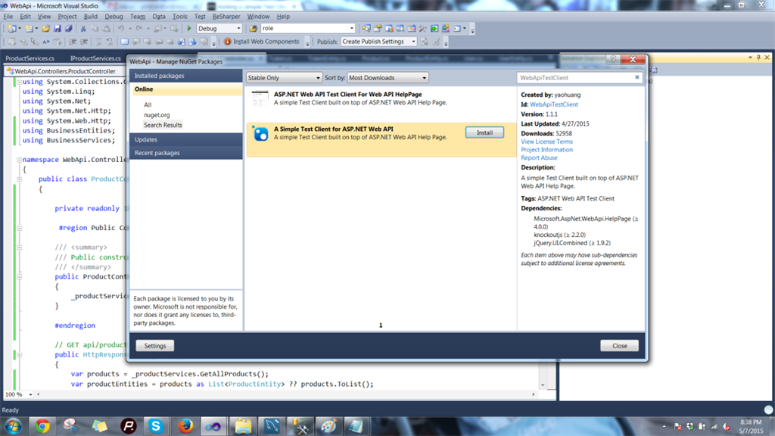

You'll get “A simple Test Client for ASP.NET Web API”, just add it. You'll get a help controller in Areas -> HelpPage like shown below.

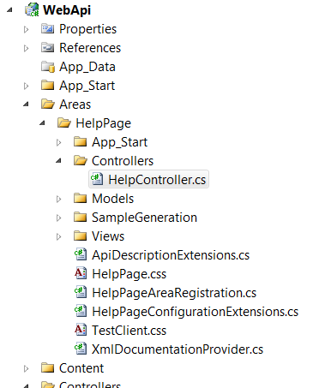

**Running the Application**

Before running the application, I have put some test data in our product table.

Just hit F5, you get the same page as you got earlier, just append “/help” to its URL and you'll get the test client as in the following:

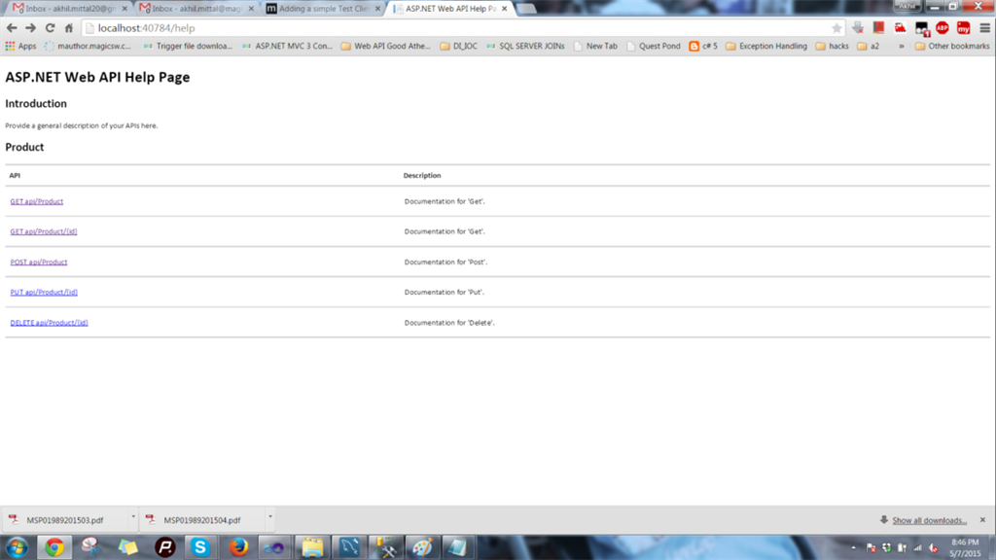

You can test each service by clicking on it.

Service for GetAllProduct:

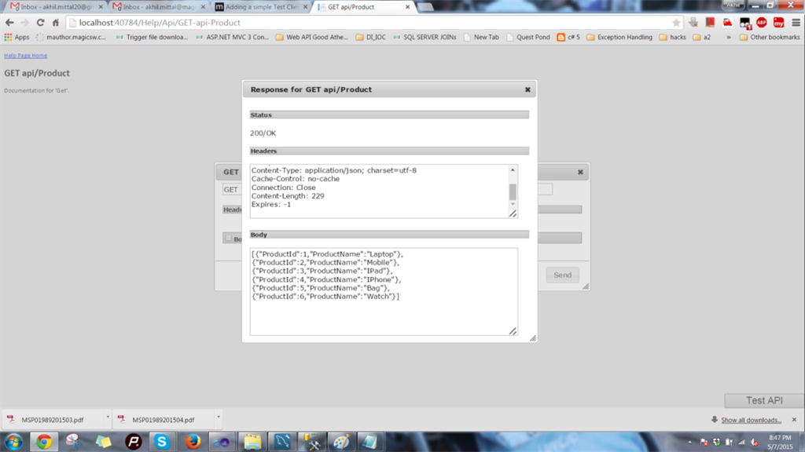

To create a new product:

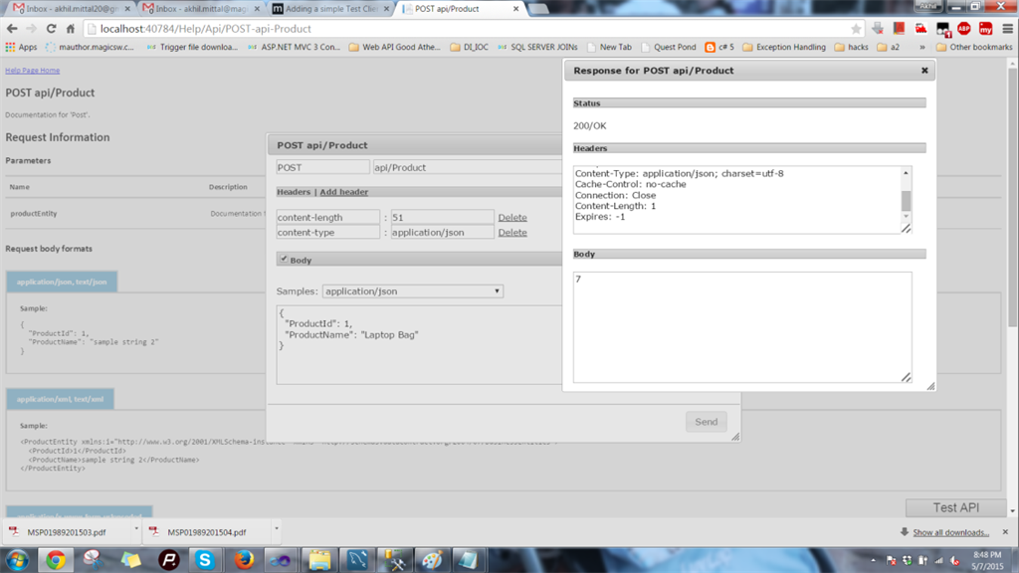

In the database, we get a new product as in the following:



Update product:

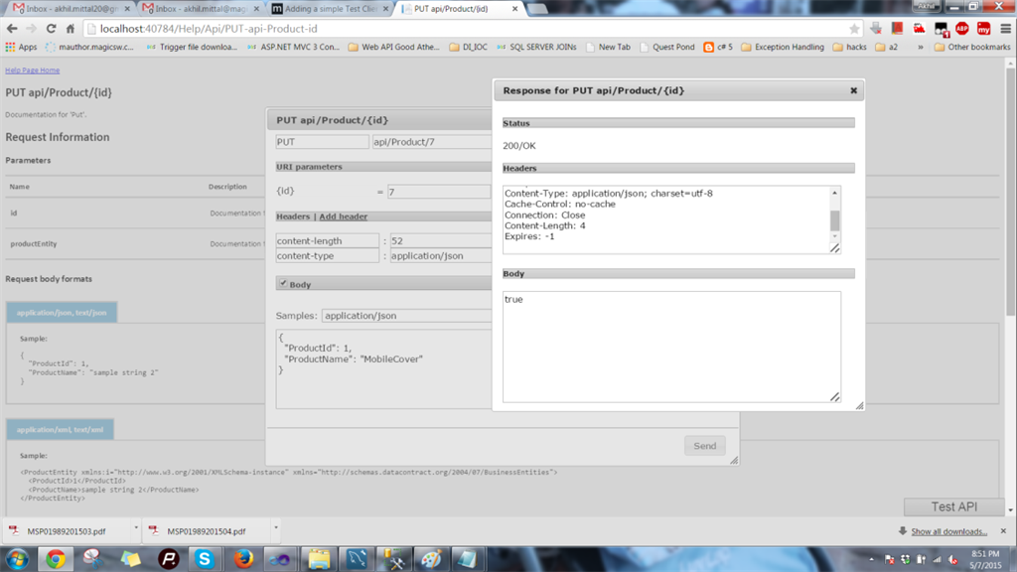

We get the following in the database:

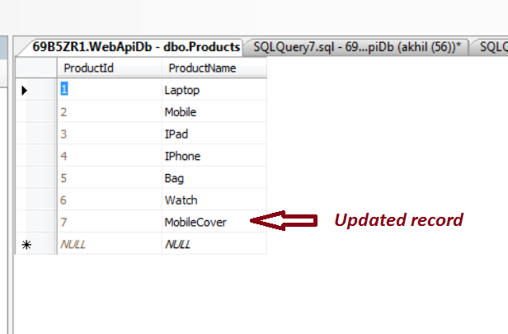

Delete product:

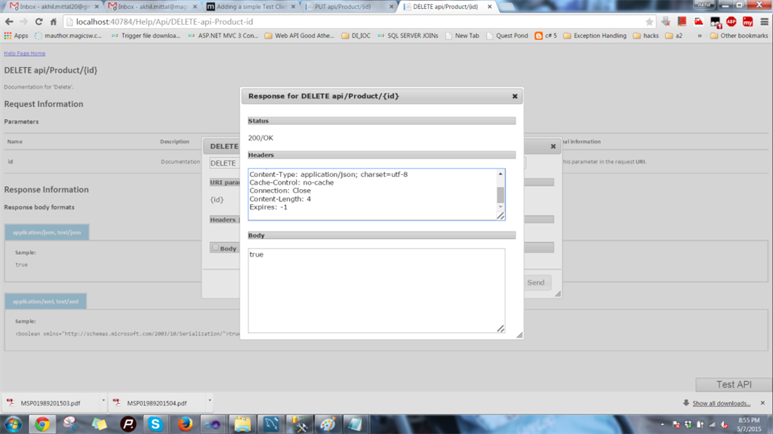

In the database:

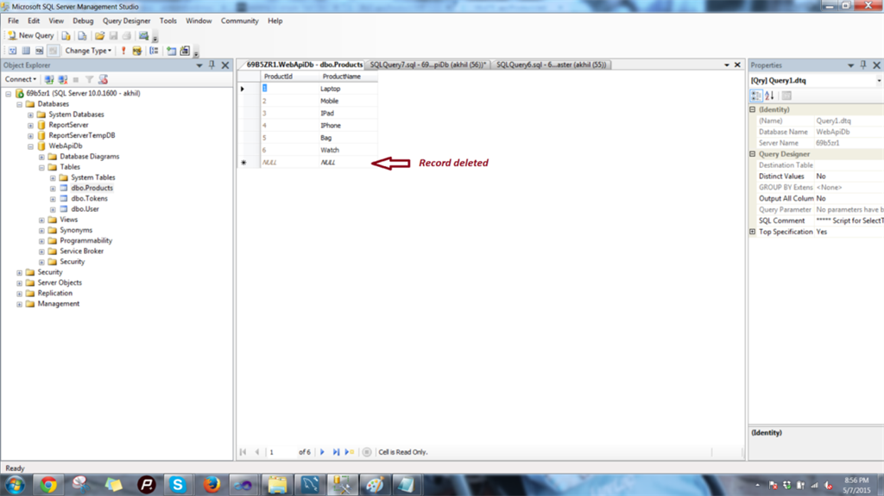

Job done.